How to run the clustering plugin

Before opening the plugin make sure that the necessary files are loaded into your current QGIS session. You will need three datasets for the plugin to function correctly:

1. **Administrative boundaries –** These administrative boundaries have to be in the form of a polygon shapefile. These administrative boundaries represent the area of interest when generating your plugins (available from multiple sources e.g. [here](https://gadm.org/)).
2. **Population –** This is the population dataset that you use as the basis of your clusters. It is recommended to use the High resolution settlement layer (HRSL) when available and if not GHSL. This map should be in the form of a raster (HRSL available at: [here](https://data.humdata.org/organization/facebook) and GHSL available at: [here](herehttps://ghsl.jrc.ec.europa.eu/))
3. **Nighttime lights –** Map of visible light during night in your area of interest. This map should be in the form of a raster. (available [here](https://eogdata.mines.edu/download_dnb_composites.html))

In order to use the plugin:

1. Open the plugin from the **Database** menu. The name of the plugin when installed will be HRSL_clusters
2. The following window will open up:

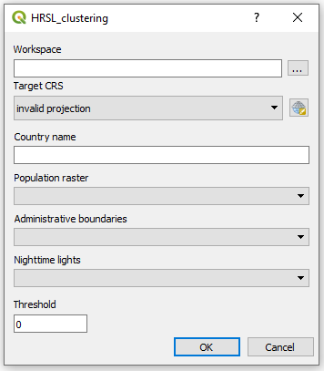

Figure 1. Plugin GUI

1. In the field named **Workspace**, click on the three dots on the right hand side of the field and navigate to an empty folder.

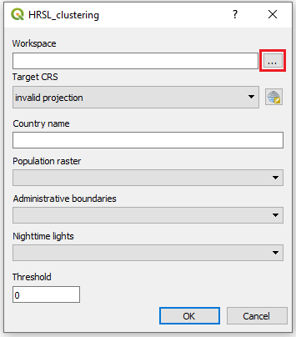

Figure 2. Select workspace.

1. Next chose the **projection system.** Make sure that the projection system is in a linear unit and that this linear unit is meters.

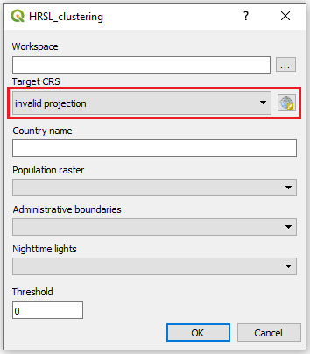

Figure 3. Select projection system

**NOTE: When selecting the projection system the following window will open up:**

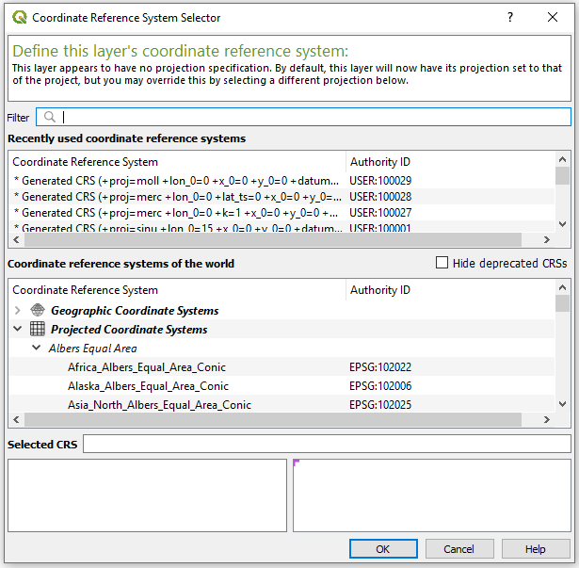

Figure 4. Projection selection window

**To find the coordinate system that is appropriate for your study area please visit** [**http://epsg.io/**](http://epsg.io/) **and search for your area of interest.**

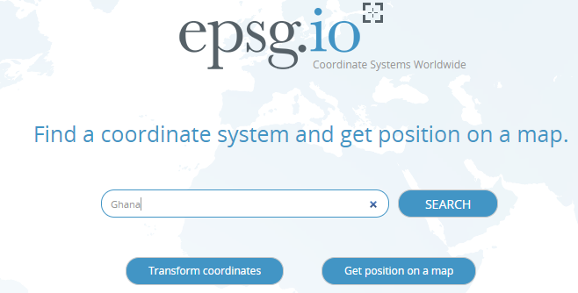

Figure 5. Go to epsg.io and search for the country you want to reproject

**This will present you with a list of coordinate systems suitable.**

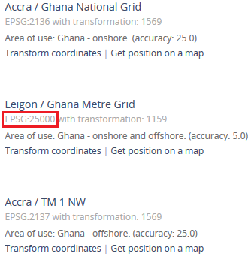

Figure 6. You will get a list of different coordunate systems that fit with your study area. Choose one and note its EPSG code.

**Next, come back to QGIS. Click on the icon next to the field and check the EPSG code received from the webpage. Choose one where the unit is in meters and the red box covers the whole area you are working with.**

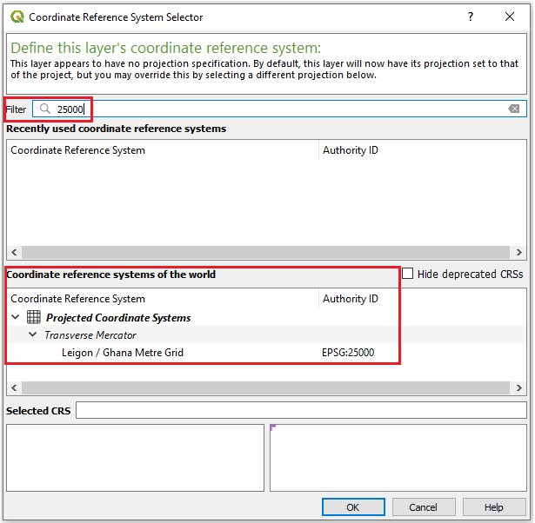

Figure 7. Enter the coordinate system you have chosen in the field. Make sure that the unit is meters (lower left box) and that the red area covers your study area (lower right box)

1. In the next three boxes select the appropriate datasets.

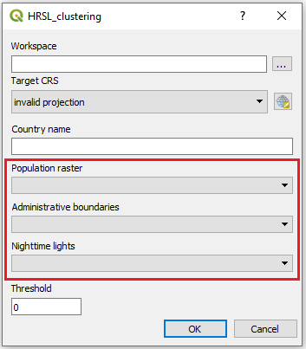

Figure 8. Enter the datasets used for the creation of the clusters

1. In the field that named threshold enter the threshold for you minimum population in each cell i.e. if you enter 2 their will not be any population raster cells below 2 included in your input data. If you leave it as zero no cells will be removed. Please note that the field only accepts integers.

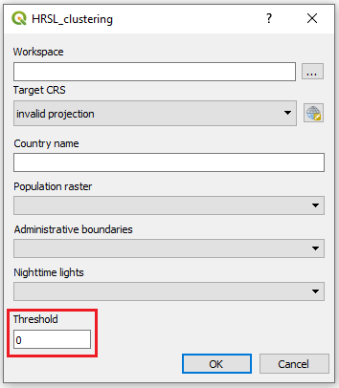

Figure 9. Enter the threshold value

1. Click on ”OK” to run the plugin.
2. Plugin may take 2-3 hours to run depending on the size of the study area. During this time QGIS can not be used. When it is finished a message will display that the plugin is done and you can close the window.